|  |  |
| --- | --- |
| Project Report | |
| Nguyen Viet Hoang Nam_ITITIU19162Huynh Duc Phat_ITITIU19177OOP_G01_L02 |  |
|  |  |

|  |  |  |  |
| --- | --- | --- | --- |
|  |  | |  |
| Pong Game | | | |
| RULE First you will have to click the “Play” button in order to start the game.  While playing, you will earn 1 point when your opponent let the ball hit their back wall.  You can either close the game by clicking on the Esc button on your keyboard or the Exit button on the game window screen. | | The two paddles return the ball back and forth. The score is kept by the numbers at the top of the screen | |
|  | |

|  |  |  |  |  |  |
| --- | --- | --- | --- | --- | --- |
|  | | | | | |
|  |  | Game classes Our project has 7 classes in this Pong game:   * **Game.java:** It contains all the game objects and uses seperated thread to manage, update the game physics. * **Window.java:** It has JFrame and adds the Game Canvas to it. * **Ball.java:** Properties for the ball to bounce. * **Paddle.java:** Properties for 2 paddles to move and properties for the Game score. * **KeyInput.java:** It takes intput from the keyboards to make both paddles moving. * **Menu.java:** It will aske the user "Play" or "Quit" at the start of the game. * **Test.java:** It will run the Game. |  |  |

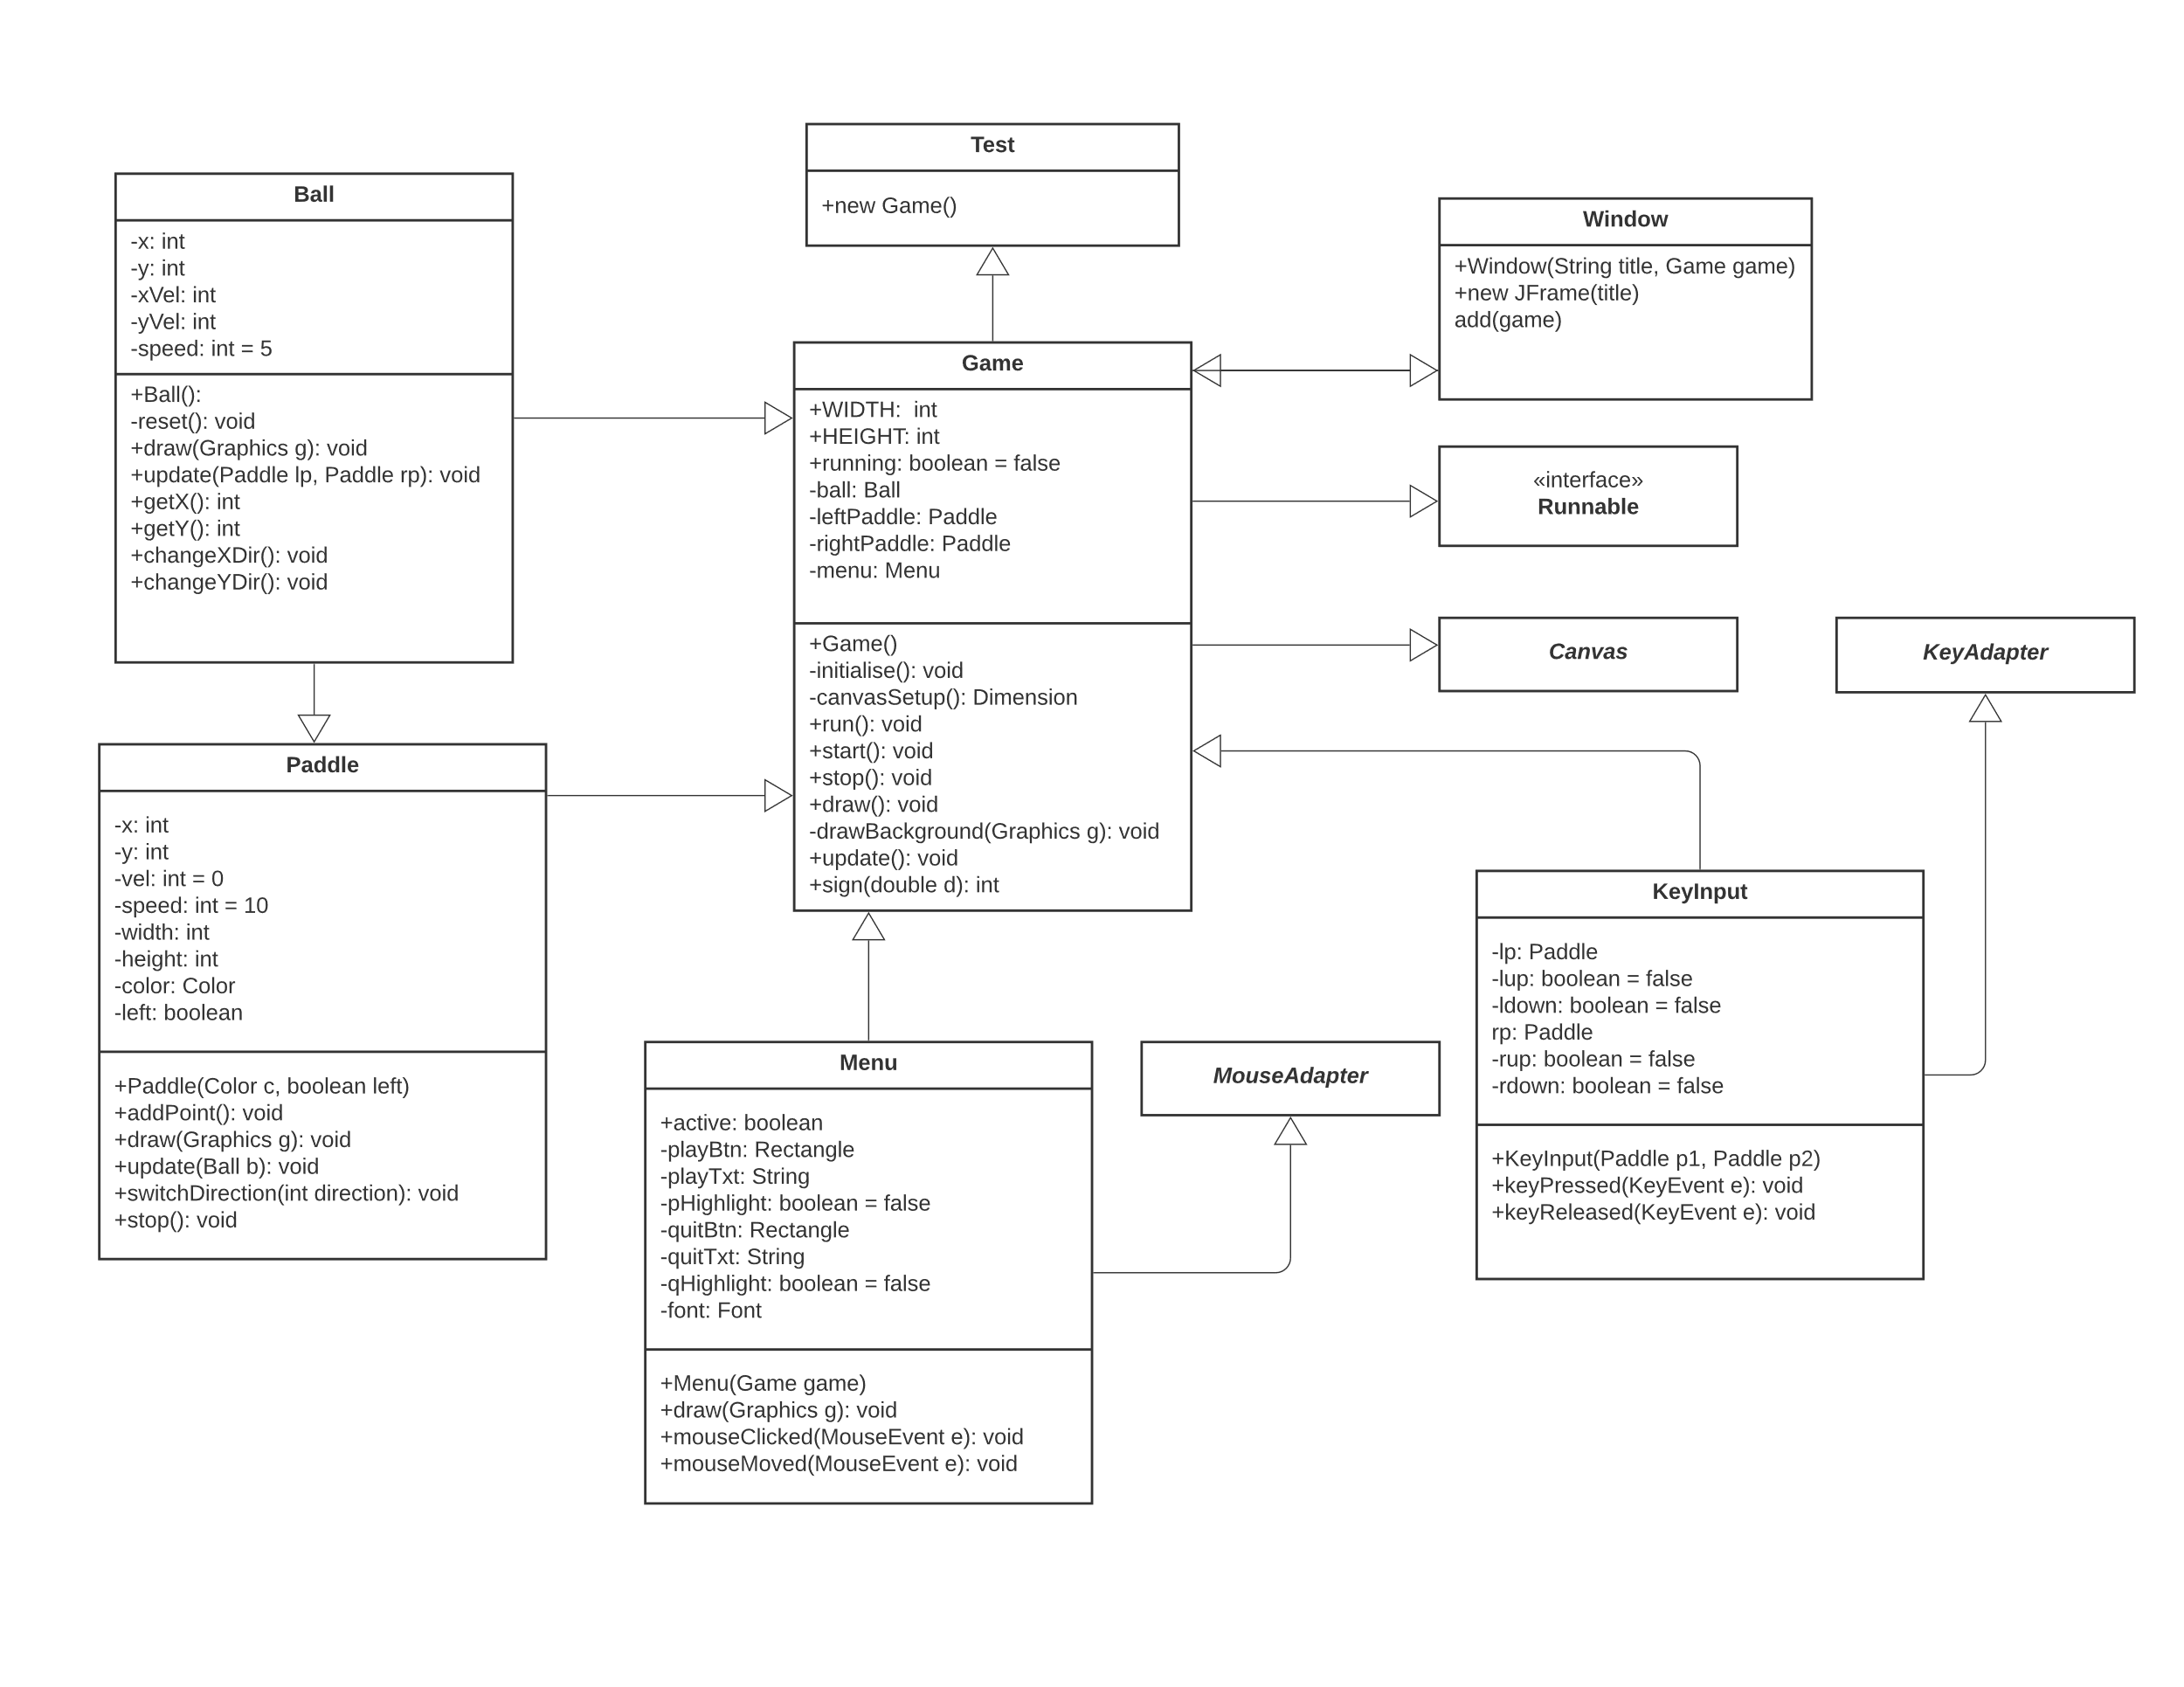

### Class diagram